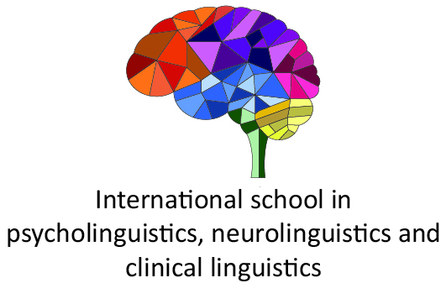

2nd International School on Psycholinguistics, Neurolinguistics and Clinical Linguistics (online)
Faculty of Philosophy, University of Novi Sad
25th - 29th October 2021

Application form

Surname:

First name:

Address:

Country:

E-mail:

Study level:

Home university:

Please state briefly your motivation for applying to the spring school:

